7th STI-Gigaku 2022 ABSTRACT SAMPLE

Shigeharu Kamado¹, Taro Nagaoka²

¹ Nagaoka University of Technology, Nagaoka, Japan 940-2188, xxx@xxx.xxx.xx
² National Institute of Technology, yyyyyyyy College, zzzzzzzz, Japan 940-2188

Keywords: Gigaku, Innovation, SGDs

IMPORTANT INSTRUCTIONS FOR ABSTRACT:
Main text begins from here (10pt, Times New Roman)
・Please prepare your abstract using this template in MS-word file (.doc or .docx). DO NOT change the template format. Your abstract may be rejected if you don’t follow the instructions indicated.
・The following information should appear at the head of the abstract with a line space between each item and before the main text ●TITLE (12pt in BOLD BLOCK LETTERS) ●Name(s) of author(s) : The presenting author should be underlined. (11pt) ●Affiliation, city, country, zip code and presenting author’s E-Mail address (10pt, Italic) ●Keywords (10pt, Italic)
・Abstracts should not exceed one page of A4 (210 x 297 mm) size
・The margin should be 25mm on left, right and bottom side, and 15mm on top side.
・You can add figures or pictures.
・Place each of main and sub SDG logo (main: 3 x 3 cm, sub: 2 x 2 cm) on the top right corner.
・Please submit in PDF file.

Nagaoka University of Technology has been promoting educational research in cooperation with the college of technologies, universities, research institutes, and company in the world.
The purposes of the international conference “STI-Gigaku” are sharing results of educational research based on “Sustainable development Goals (SDGs)”, development of educational research, and formation of an international network.

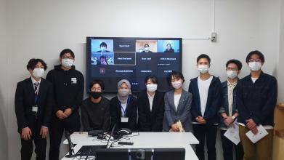
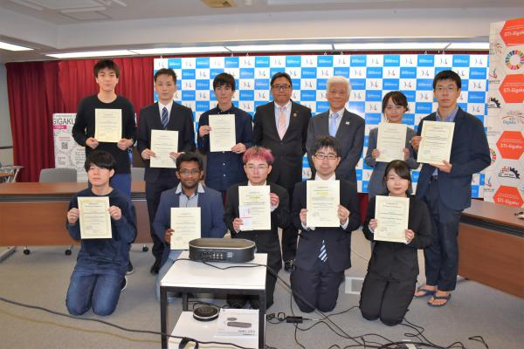
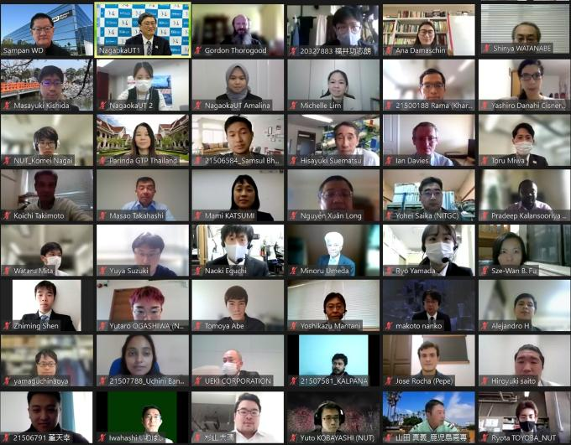
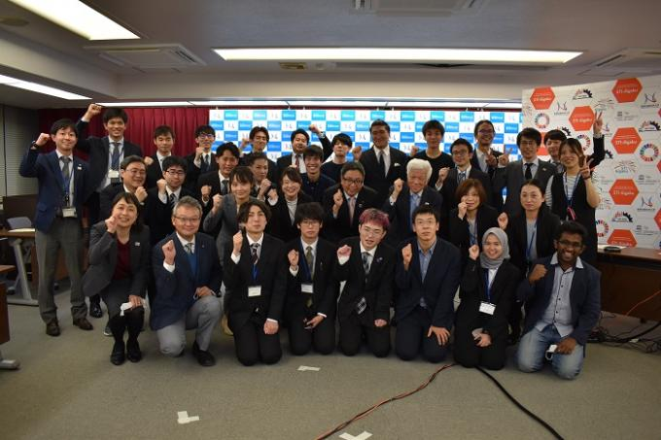
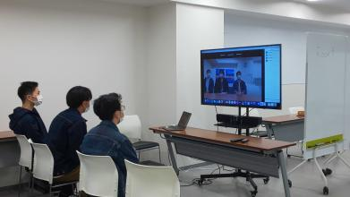

Fig.1 Highlight of 6th STI-Gigaku 2021

REFERENCES (9pt)
- Author(s), Article title, Journal name, XX (YEAR) XX-XX

